**Hackathon project phases template for the GEMINI PRO FINANCIAL DECODER PROJECT**

Hackathon Project Phases Template

# Project Title:

# Gemini Pro Financial Decoder

# Team Name:

Gemini Market Mind

# Team Members:

* Rodda Sai Prasanna
* Tatepally Sravanthi
* Nalapala Srivarsha

# Phase-1:Brainstorming &Ideation

## Objective:

To develop advanced AI capabilities to decode , “Analyze , and interpret financial data , Transforming complex financial information into actionable insights for investors , Analystics , And businesses , enabling smarter decision – Making and improved financial outcomes”.

## Key Points:

1. **Problem Statement :**

* Financial professionals need tools that provide up-to-the- minute insights to make informed, Timely decisions, but many systems offers outdated information.
* Many information have multiple financial platforms that don’t integrate well , leading to fragmante and incomplete data insights .
* Businesses and investors struggles with identifying and mitigating risks effectively due to a lack of real-time analysis.

1. **Proposed Solution:**

* Allows user to quickly grasp key trends, risks, and insights without needing to deep-dive into raw data .
* It helps businesses and investors make more informed, timely decisions and reduces the risk of outdated information influencing strategy.
* It enables users to plan a head by anticipating market shifts , improving risk management ,and optimizing investment strategies.

1. **Target Users:**

* The decoder can simplify complex data , provide predictive analytics, and generate customized reports , Making their analysis faster and more accurate .
* Real-Time data, predictive insights ,and risk management features could help them optimize investment strategies and reduce risk exposure.
* This tools can help CFOs monitor financial performance , forecast future trends , and generate reports to present to stake holders, improving decisions-making efficiency.

1. **Expected Outcome:**

* Financial professionals will be able to make data-driven decisions faster and with greater confidence.
* It enhances risk management.
* The tools having low operational cost .

# Phase-2:Requirement Analysis

## Objective:

Define the technical and functional requirement for the GEMINI PRO FINANCIAL DECODER.

## Key Points:

1. **Technical Requirements:**

* Programming Language :**Python**
* Backend :**REST ful APIs or web sockets**
* Frontend: **Stream lit Web Framework**
* Database: **Not required initially(API-based queries)**

1. **Functional Requirements:**

* The system should update prices ,market trends and news feeds in real-time.
* To Display live financial data and price tickers.
* Allows user in Real-time updates without needling page reloads.

1. **Constraints & Challenges:**

* Ensuring real-time updates from **Gemini API**.
* Complexity for New users.
* Depends on data quality

# Phase-3:Project Design Objective:

Develop the architecture and user flow of the application.

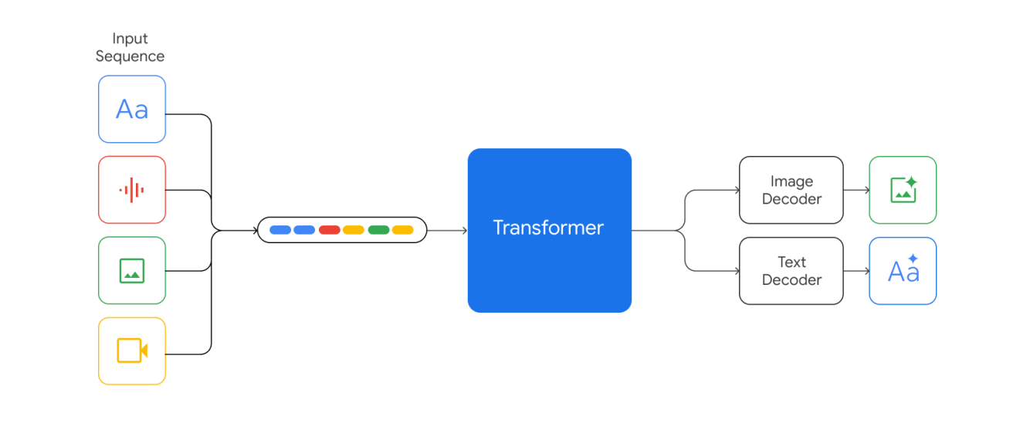

## Key Points:

1. **System Architecture:**
   * Data ingestion and processing-collects financial data.
   * AL and ML models-uses NLP & time-series forecasting with PyTorch.
   * Finanical decoder module using GEMINI PRO API.
   * API and frontend-provides insights RESTAPIs ,web sockets and dashboards.
   * Cloud and security deployed on GCP/AWS.
2. **User Flow:**
   * Step1:User input and data collection(e.g.,"text , news, stock prices ,voice ,or API").
   * Step2:Data processing and preprocessing.
   * Step3:AI model generates insights & visualizations.
3. **UI/UX Considerations:**
   * **Minimalist, intuitive interface** for seamless navigation.
   * **Real-time updates, interactive chats, personalization &customization**.
   * **User authentication ,data privacy compliance** for better user experience.

# Phase-4:Project Planning (Agile Methodologies)

## Objective:

Breakdown development tasks for efficient completion.

|  |  |  |  |  |  |  |  |
| --- | --- | --- | --- | --- | --- | --- | --- |
| **Sprint** | **Task** | **Priority** | **Duration** | **Deadline** | **Assigned To** | **Dependencies** | **Expected**  **Outcome** |
| Sprint 1 | Environment Setup & API Integration | 🔴High | 6 hours  (Day 1) | End of Day  1 | R . Sai prasanna | Google API Key, Python, Stream lit setup | API connection established &working |
| Sprint 1 | Frontend UI Development | 🟡  Medium | 2 hours  (Day 1) | End of Day 1 | N . Sri varsha | API response format finalized | Basic UI with input fields |
| Sprint 2 | Gemini Pro Financial Decoder | 🔴High | 3 hours  (Day 2) | Mid-Day 2 | Sai prasanna & srivarsha | API response ,UI elements ready | Search functionality with filters |
| Sprint 2 | Error Handling & Debugging | 🔴High | 1.5 hours  (Day 2) | Mid-Day 2 | Saiprasanna & sravanthi | AP I logs ,UI inputs | Improved API stability |
| Sprint 3 | Testing & UI Enhancements | 🟡  Medium | 1.5 hours  (Day 2) | Mid-Day 2 | Sri varsha & Sravanthi | API response ,UI layout completed | Responsive UI, better user experience |
| Sprint 3 | Final Presentation & Deployment | 🟢Low | 1 hour  (Day 2) | End of Day 2 | R . Sai Prasanna  N .Sri varsha  T . Sravanthi | Working prototype | Demo-ready project |

## Sprint Planning with Priorities

**Sprint1–Setup&Integration (Day1)**

**(**🔴**High Priority)** Setup the **environment** &Install dependencies.

**(**🔴**High Priority)** Integrate **Google Gemini API**.

**(**🟡**Medium Priority)**Build a **basic UI with input fields**.

## Sprint2–CoreFeatures & Debugging (Day2)

**(**🔴**High Priority)**Implement **search & comparison functionalities**.

**(**🔴 **High Priority)** Debug API issues & handle **errors in queries**.

## Sprint 3 –Testing , Enhancements &Submission (Day2)

**(**🟡**Medium Priority)**Test API responses , refine UI ,& fix UI bugs.

**(**🟢**Low Priority)** Final **demo preparation & deployment**.

# Phase-5: Project Development

## Objective:

Implement core features of the GEMINI PRO FINANCIAL DECODER

## Key Points:

1. **Technology Stack Used:**
   * **Frontend:** React.js ,Next.js ,vue.js
   * **Backend:** Fast API, Flask , g RPS
   * **Programming Language:** Python
2. **Development Process:**
   * Implement ML like tensor flow, PYTorch and NLP process as Gemini pro API .
   * Develop Google cloud, AWS ,azure AI.
   * Encryption and access control and regulatory compliance.
3. **Challenges &Fixes:**
   * **Challenge :**Real-time data accuracy- financial data can outdated due to delays.

**Fix:** uses APIs with low latency data.

* + **Challenge:** Bias in financial predications-AI models over fit to market trends.

**Fix:** uses in memory databases and efficient streaming architecture

# Phase-6:Functional &Performance Testing

## Objective :

Ensure financial decoder App works as expected.

|  |  |  |  |  |  |
| --- | --- | --- | --- | --- | --- |
| **Test Case ID** | **Category** | **Test Scenario** | **Expected Outcome** | **Status** | **Tester** |
| TC-001 | Functional Testing | Retrives real- time stock data . | Data is fetched and stored in database. | ✅Passed | Tester1 |
| TC-002 | Functional Testing | System prevents SQL injection and XSS attacks. | Malicious input rejected &system logs security threats. | ✅Passed | Tester2 |

|  |  |  |  |  |  |
| --- | --- | --- | --- | --- | --- |
| TC-003 | Performance Testing | 50 users request real-time stock trends and risk analysis. | Dashboard updates smoothly with minimal latency. | ⚠ Needs Optimization | Tester3 |
| TC-004 | Final  Validation | Real time stock market data ingestion. | Data updates without delay | ✅Fixed | Develop er |
| TC-005 | Final Validation | Verify multi user access and role base permissions. | Users can only access authorized data based on roles. | ❌Failed - UI | Tester2 |
| TC-006 | Deployment Testing | Deploy a new version and test rollback. | Rollback complete successfully without downtime. | passed | Develops |

## 

# Conclusion :

# 

The GEMINI PRO FINANCIAL DECODER appears to be a Financial Tool designed to

Interpret , Analyze , and provide insights into complex financial data. Whether it’s focused on real-time

Market analysis , trending signals , or decoding intricate financial patterns , the core function would

Likely center around simplifying vast data sets for users, such as traders , analysts or investors .

# FinalSubmission

1. **ProjectReportBasedonthetemplates**
2. **DemoVideo(3-5Minutes)**
3. **GitHub/CodeRepositoryLink**
4. **Presentation**